Chapter Four
PRELIMINARY DESIGN
4.1 Concept Generation
This project was assigned to us at the beginning of the semester after the group formation process was completed. At first glance we were excited about the nature of the project as it seemed to present enough of a challenge. Our first order of business was to come up with an overview of how we would handle the project as well as possible design options. We met with our NAVSEA mentor who shed some light on the different design options and their various constraints. We knew we would have to tackle tasks such as navigation, power management, control, communication just to name a few.
During subsequent meetings we brainstormed and exchanged ideas to try and come up with an efficient preliminary design. One option was to utilize cameras as feedback sensors for navigation purposes as opposed to a navigation compass with no cameras incorporated. Also for power management we contemplated on solar power versus swappable lithium ion batteries. Some of the other considerations we had to take included the type of cpu for the control system and the number and type of thrusters we would use. After that final brainstorming session we had come up with two preliminary designs.

4.2 Concept Evaluation and selection
Our main goal was mostly to have the AUV make it through the gate which is the primary task for the competition. We decided that we could still achieve efficient navigation without the camera by using different types of sensors such as depth sensor, pressure sensor and a compass. The camera option being too time consuming given that it is our first entry to the competition. Since we decided to focus on the main task, we eliminated the grabber and the torpedo and decided to focus more on the power management and the weight of the vehicle.
Computer | Thrusters
Motor Controller | Compass
Batteries | IMU
Kill Switch | Hydrophones
GPIB/GPIO | Cameras
Tethering | Pressure Sensor
Table 4.1 Parts list

4.3 Preliminary Analysis
After brainstorming and looking at previous pre-existing models, we wanted our first design to implement six thrusters, allocating two for up/down movements, two for right/left movements and two for forward movement. To power the vehicle, we will use two rechargeable batteries (Lithium Ion) swappable and connected in series. For navigation purpose we will use a gyroscope and a compass. Different sensors will be implemented on the vehicle to determine the pressure, the temperature and the depth. The most important part of our design is the electric module (computer) were all the processing of information will happen. All the components will be interfaced to the module where it will receive and transmit data.

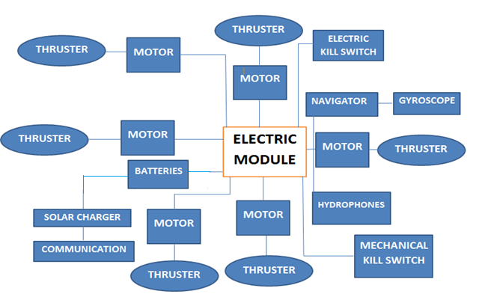
Figure 4.1 Design Concept One

For our second design we made some improvements based on the budget that was allocated to us. We will use a new set of thrusters that have motors already implemented and we will ad cameras at three different locations on the vehicle to facilitate the monitoring and navigation.

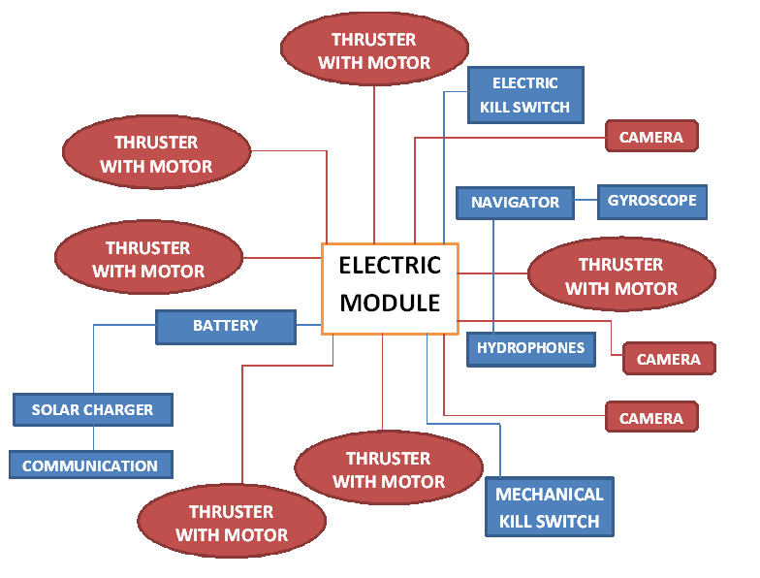
Figure 4.2 Design Concept Two

