Chapter Three
LITERATURE REVIEW
INTRODUCTION
An Autonomous Underwater Vehicle (AUV) is a vehicle that is designed to work under water without input from an external user. This type of control means that they are inherently difficult to control with precision. Our objective as a group is to engineer and design the electrical system that will be used for an AUV that will be placed in a competition to complete a series of very specific tasks. In this summary we will cover all of the main electrical components and how they are used on existing robots that are currently on the market.
OVERVIEW
The typical AUV design consists of a pressure hall with dimensions determined based on material, weight and accessories. There is at least one dry compartment to house the electronic
component and power supply as shown in picture c of figure 1 below.
Sensors are generally waterproofed and mounted on the exterior of the AUV. Propulsion is handled by the use of thrusters with at least two thruster motors with propeller blades mounted in the horizontal plane on the left and right rear half of the vehicle and responsible for forward, reverse, left and right motions depending on the direction in which the propellers are turned. Two additional thrusters are mounted in the vertical plane and they are responsible for upward and downward motion of the vehicle [1].

Figure 3.1: Schematic for AUV obtained from the Control, Automation, Robotics and Vision Conference, 2004.
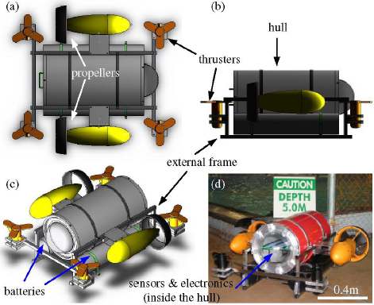

ICARCV 2004 Authors: Arshad, M.R.; Radzak, M.Y

Control of the vehicle is achieved by utilizing a master controller which receives feedback from a collection of sensors for decision making. Some applicable sensors may include a compass module for heading control and a thermal accelerometer for speed and stabilization control. The control system can be designed using different underwater robot control systems such as sliding control, learning control and adaptive control. Figure 2 below shows a block diagram flowchart of a typical AUV control system. A low level controller design which uses depth, speed and vehicle heading as its parameters would be a cost effective and more simplistic option. These parameters receive a command from their mission planner and react to the environment for reaching the desired goal [1]. Line of sight guidance rules are also used to maintain path tracking by looking ahead to planned waypoints in camera incorporated vehicles. Most of the AUVs operate from a range of 1000 meters or deeper of water depths. One of the deepest rated AUVs is the US Navy's AUSS, designed to operate at 6,500 meters. The speed of the AUV is an important factor; however, average speed and endurance may be more important. There is a broad spectrum of speeds among AUV units. Stanford's experimental Otter has a presumed top speed of 0.5 kts, whereas ISE's Dorado flies along at a top speed of 17.5 kts, with an average speed of 10 kts. An AUV's endurance depends upon speed, mission requirements, payload, battery type, and is quantified in both time and distance. Currently, Underwater Research Lab's Purl II operational limit is 2.5 hours, whereas Webb Research Corp's Slocum can operate up to 5 years. At the beginning they were mostly used for US military applications like tactical oceanography and anti-submarine warfare by the US NAVY. Today with the improvements in computer, sensors and batteries, scientists have developed remarkable AUV’s to expand knowledge and understanding of the oceans [4].
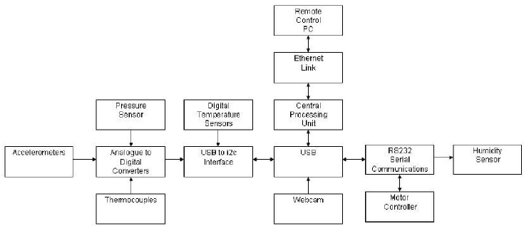

Figure 3.2: Example of electronics control system flowchart for AUV

POWER SUPPLY AND MANAGEMENT
The ideal location for the power supply for an AUV is onboard the vehicle and due to the multiple electric systems present in the vehicle sealed lead acid batteries could be used. The battery choice is due to their high capacitance and their ability to deliver higher currents than other rechargeable batteries [2]. We will go with the option of hot-swappable batteries that can be recharged through solar panels at an external charging station. The issues with using solar power to charge a device such as the Underwater Autonomous Vehicle is the charge time and the creation of a monitoring system to prevent any overcharging or undercharging of the battery. Monitoring would have to be able to identify the charge and discharge rate of any battery type used as each type has a different rate and life cycle of use. The best type of batteries for use with our system would be Lithium Polymer type as it has the highest discharge current ability due to secondary cells hooked up in parallel with one another [5]. These batteries are easier to find in packs made to increase the amount of voltage available to the system. Efficiency of Lithium Polymer is very close to 100 percent, approximately 99 percent when compared to other rechargeable batteries. Lithium batteries also lose their charge slower when not being used in a system so they have a longer shelf life. You can charge the Lithium Polymer up to five hundred times before its capacity drops below 100 percent.
The lithium polymer can be easily adapted to charge via solar power or bought with the skill to use solar. Adafruit sells a small 6v solar panel kit to provide a charge to a lithium ion battery. In addition to charging kits by Adafruit, Idronaut produces a lithium battery specifically designed to operate underwater to a purchasers specific goals [6]. Purchasing a solar rechargeable powered battery setup is much simpler than creating one and can be ordered with any parameter in mind. In summary we will use modified Lithium battery using solar panels for charging at an outside source. The modification and installation of the battery will depend on the exact power needs to operate the machine and components for prolonged activity underwater and reduce the risk of explosion [7]. Efficient designs utilize several batteries to make sure enough power is delivered to the electronics and these batteries will act as dead weight and help buoyancy. Enclosing the batteries in a separated compartment from the rest of the electronics could be advantageous during battery swapping.
SOFTWARE INTERFACE AND CONTROL SYSTEM
One of the most important, if not the most important things that need to be considered for a successful AUV is the software that will be implemented in the electronics. Since the robot is autonomous, it must be able to run a series of tasks on its own and be able to resolve problems that are encountered without user interference. From a control viewpoint, the non-linear, time varying nature of the underwater robot, together with uncertainties in the hydrodynamic coefficients, makes the underwater vehicles a challenging system to be controlled [3]. What this means to us as engineers is that we must be able to develop a software platform that is able to account for all of the uncertain properties that are inherent in water. A couple of key hardware components that are needed to complete an AUV are the compass, and IMU. For a robot to control itself properly we must program our robots interface to respond to precise inputs from these two devices. These devices are extremely vital to the control and manipulation of the robot, and if programmed correctly we should be able to respond to any uncertainty that we encounter in the water.
Next on the list of importance is the hardware that will be used on the AUV. The article that I found on IEEE lists a few of the major components that will be used on the robot. These components and their features are listed below [3]:
- Inertial Measurement Unit (IMU): MTi from Xsens. For accurate real-time attitude and orientation of the vehicle.
- Depth: Cerabar T PMP 131 from Endress+Hauser, analog sensor. Used to determine the operation depth of the AUV.
- Battery Level: analog sensor. Estimate the status of the battery based on the voltage and current level’s.
- Thruster rpm: digital sensor. Provide the revolutions of the main propulsion thruster.
- IMU, this sensor it also used to generate an Inertial Navigation Solution (INS).
Depth sensor: used to improve the INS.
These components are often used on a commercial AUV, but for our project we will focus more of our attention to the IMU, because it has the most important information that will be needed in the coding process. Our application of the IMU will be used in the same manner that is used by any other AUV/ROV on the market. The purpose of the IMU is to provide the attitude and rate of turn of the vehicle, essential variables for the control loop [3]. So what is used to interface these components to the main processor in the AUV? The answer is communications. The two most commonly used forms of transmitting information from one component to the next are RS-232 serial connections and Ethernet TCP/IP connections. The difference between the two is that RS-232 is a hardwired connection whereas TCP/IP is a wireless connection. Both of these means of communication can be used in the development of our robot and of currently marketed robots

